Name: ________________________ Date: ________________

**ATHBY Unit 4 2023**

**Task 5: Science Inquiry 2023**

**Task Description**: A case study analysis on gene therapy and its potential therapeutic application toward diseases; sickle cell anaemia and thalassemia. This will be followed by a short validation test based on the article, relevant Science Inquiry Skills and Science Understanding covered in Unit 4 that are relevant to article.

**Conditions:**

**Part A:**

* Read & annotate printed material provided.
* In order to prepare for the in-class assessments you will be given time at home to take notes on the material and topics covered.
* 5 marks will be assigned for completed notes. 2 marks from this will be allocated for references.

The remaining three marks will be allocated using the table below.

**It is recommended that you review chapter 1 from your text in your notes**

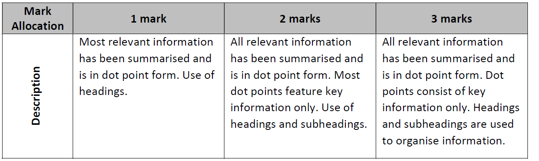

**Part B:** Complete in-class assessment. This task will be made up of 8 questions, worth a total of 25 marks and will take 40 minutes to complete.

* Pre- assessment sheet allowed. No notes

**Time for task: 40 min**

**Task weighting: 6 % Total Marks:30**

Name: ________________________ Date: ________________

**Task 5: Pre-assessment reading**

**What is Sickle cell anaemia?**

Sickle cell anaemia [or sickle cell disease (SCD) is a genetic blood disorder](https://www.nhlbi.nih.gov/health-topics/sickle-cell-disease) that affects haemoglobin, the oxygen-transporting molecule in red blood cells and impacts millions of people worldwide. Sickle cell disease causes the body to produce haemoglobin S, an abnormal form of the molecule that distorts the shape of red blood cells (resembling a sickle), disrupting their function.

Sickle cell anaemia is caused by a specific single nucleotide mutation in the beta-globin gene, which results in crescent or sickle-shaped red blood cells. Beta thalassemia is caused by a different type of mutations in the same gene, which results in lower levels of haemoglobin. Current treatment options for sickle cell anaemia and beta thalassemia are currently limited.

Current treatments involved patients receiving frequent blood transfusions and medications which are used to relieve the pain caused by the symptoms of the disease attacks or reduce symptom frequency.

**The CTX001 therapy takes an alternative approach**

Foetal haemoglobin (HbF) is a form of haemoglobin in foetuses that has the same function as regular haemoglobin but does not feature a beta-globin subunit (uses gamma-globin instead). After birth, production of this form of haemoglobin is suppressed and is substituted by the regular form of adult haemoglobin (HbA) This form features the beta-globin subunit.

CTX001 is an autologous therapy, wherein a patient’s own cells are edited and used for the treatment.

Haemopoietic stem cells were surgically extracted from the bone marrow of trial participants. Then, CRISPR is used to edit the BCL11A gene. This gene is a repressor of foetal haemoglobin (Hbf) expression in cells. Editing of this gene restores foetal haemoglobin levels and studies are commencing to see if this change can circumvent the harmful effects of deleterious mutations in both diseases and afford a normal life for patients.

In first stage clinical trial, edited stem cells were introduced back into two patients, and their progress was monitored through regular check-ups every few months.

* Patients involved in the trial received a single intravenous infusion of CTX001 and levels of haemoglobin were measured each month
* Patient A had sickle cell anaemia and Patient B had Beta thalassemia
* The trial included a sample size of n=2 and eligibility was limited to patients who were between the ages of 18 and 35 years.

References:

*Text adapted from website:* [*https://www.synthego.com/crispr-sickle-cell-disease*](https://www.synthego.com/crispr-sickle-cell-disease)

*Data adapted from article: Frangoul H, Ho TW, Corbacioglu S. CRISPR-Cas9 Gene Editing for Sickle Cell Disease and β-Thalassemia. Reply. N Engl J Med. 2021 Jun 10;384(23):e91. doi: 10.1056/NEJMc2103481. PMID: 34107197.*

Figure 1 on shows data collected from Patient A who has sickle cell anaemia. Change in each type of haemoglobin over time was measured in amount per volume (g/dl) and % of total Hb.

**Figure 1- Patient A**

Name: ________________________ Date: ________________

**ATHBY Unit 4 2023**

**Task 5: Gene therapy- Validation ____ / 25**

Figure 2 below shows changes in haemoglobin over time in (g/dl) in a patient with Beta Thalassemia who received the CTX001 infusion

**Figure 2- Patient B**

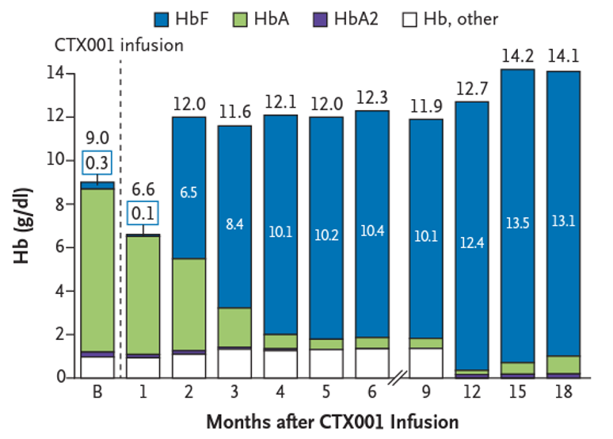

1. Use table below to calculate the Percentage Change (%) between Patients A and B for Month 5 and 6. (2 marks)

|  |  |  |  |
| --- | --- | --- | --- |
| **Month after Infusion** | **Patient A (% HbF)** | **Patient B (% HbF)** | **Percentage (%) Change** |
| 1 | 0.8 | 1.5 | 0.7 |
| 2 | 25.9 | 54.2 | 29.2 |
| 3 | 37.2 | 72.4 | 35.2 |
| 4 | 46.6 | 83.5 | 36.9 |
| 5 | 48.6 | 85 |  |
| 6 | 47.3 | 84.6 |  |

1. With reference to the data provided for patient A and B, state **two** conclusions that can be

drawn from the trial. (2 marks)

|  |
| --- |
|  |
|  |
|  |
|  |

1. Explain the level of confidence you would have in recommending CTX001 treatment based on

these study results (2 marks)

|  |
| --- |
|  |
|  |
|  |
|  |

1. After considering the data and your conclusions, what treatment advice would you provide to a

patient with sickle cell anaemia.

Explain your response, referring to data provided in **Figure 1.** (3 marks)

|  |
| --- |
|  |
|  |
|  |
|  |
|  |
|  |

1. Propose **two** changes that could be made to the study’s experimental design to improve the reliability or validity of data collected.

In your answer, identify if this change increases reliability or validity and then describe how this occurs.

(6 marks)

|  |
| --- |
|  |
|  |
|  |
|  |
|  |
|  |
|  |
|  |
|  |

1. Within one family it is common to find multiple individuals who have a mutation that cause

sickle cell anaemia.

What does this tell you about where the original mutation occurred? Justify your response.

(2 marks)

|  |
| --- |
|  |
|  |
|  |
|  |

Both variants of thalassemia, alpha and beta thalassemia provide resistance to malaria. Variants of alpha thalassemia provide resistance to malaria with little clinical complication whereas most beta thalassemia variants have significant effects on health. These effects include changes to the skeleton growth, iron overload and death from infection.

1. Describe how the link between the alpha thalassemia allele and malaria can lead to changes in

the allele frequencies in a population. (4 marks)

|  |
| --- |
|  |
|  |
|  |
|  |
|  |
|  |
|  |
|  |

1. Describe mechanisms underpinning the theory of natural selection that produce changes in a

gene pool. (4 marks)

|  |
| --- |
|  |
|  |
|  |
|  |
|  |
|  |
|  |
|  |